Kaleb Johnsen Site Plan
Wireframe
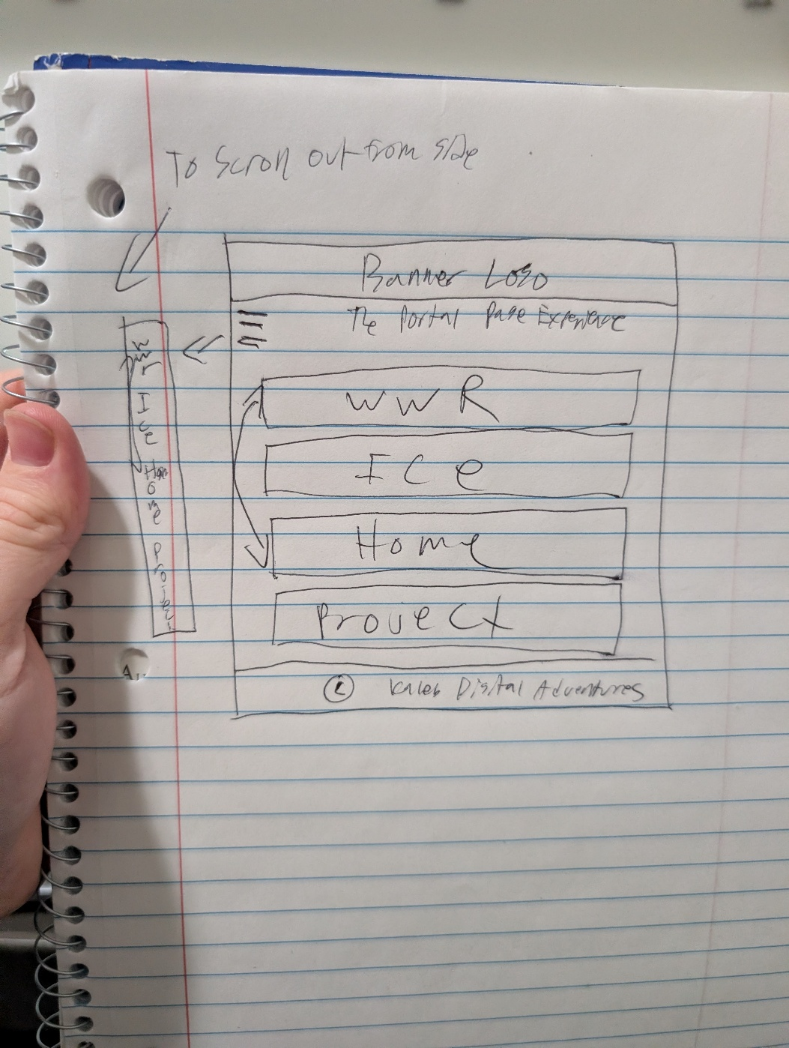
Logo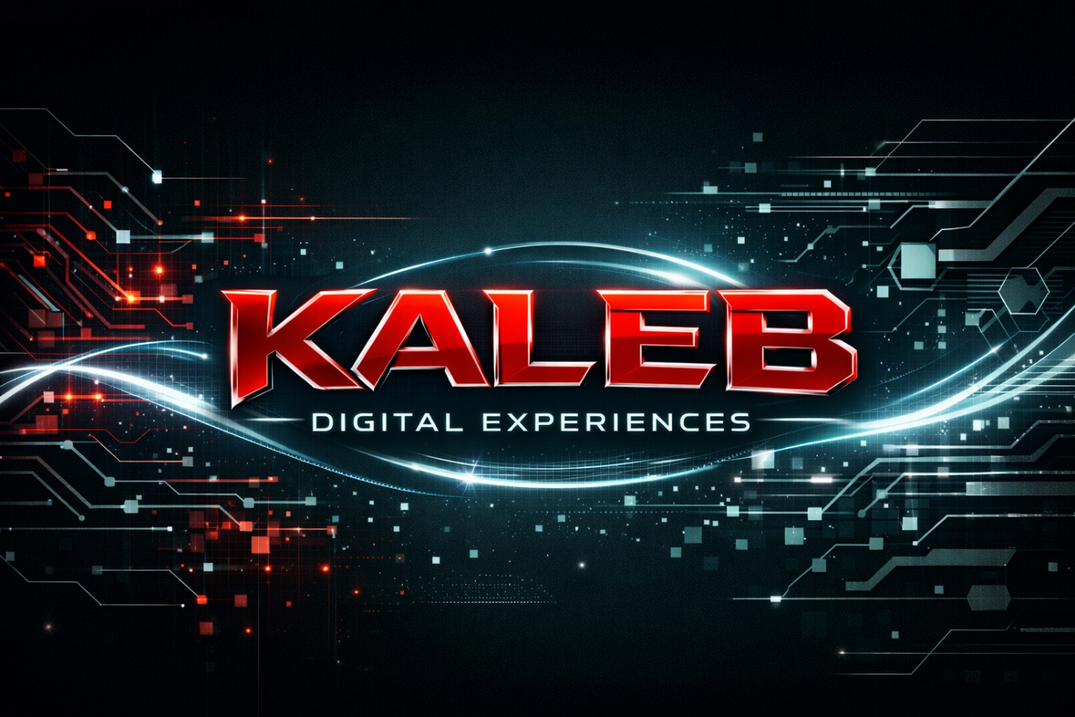
Background


Colors
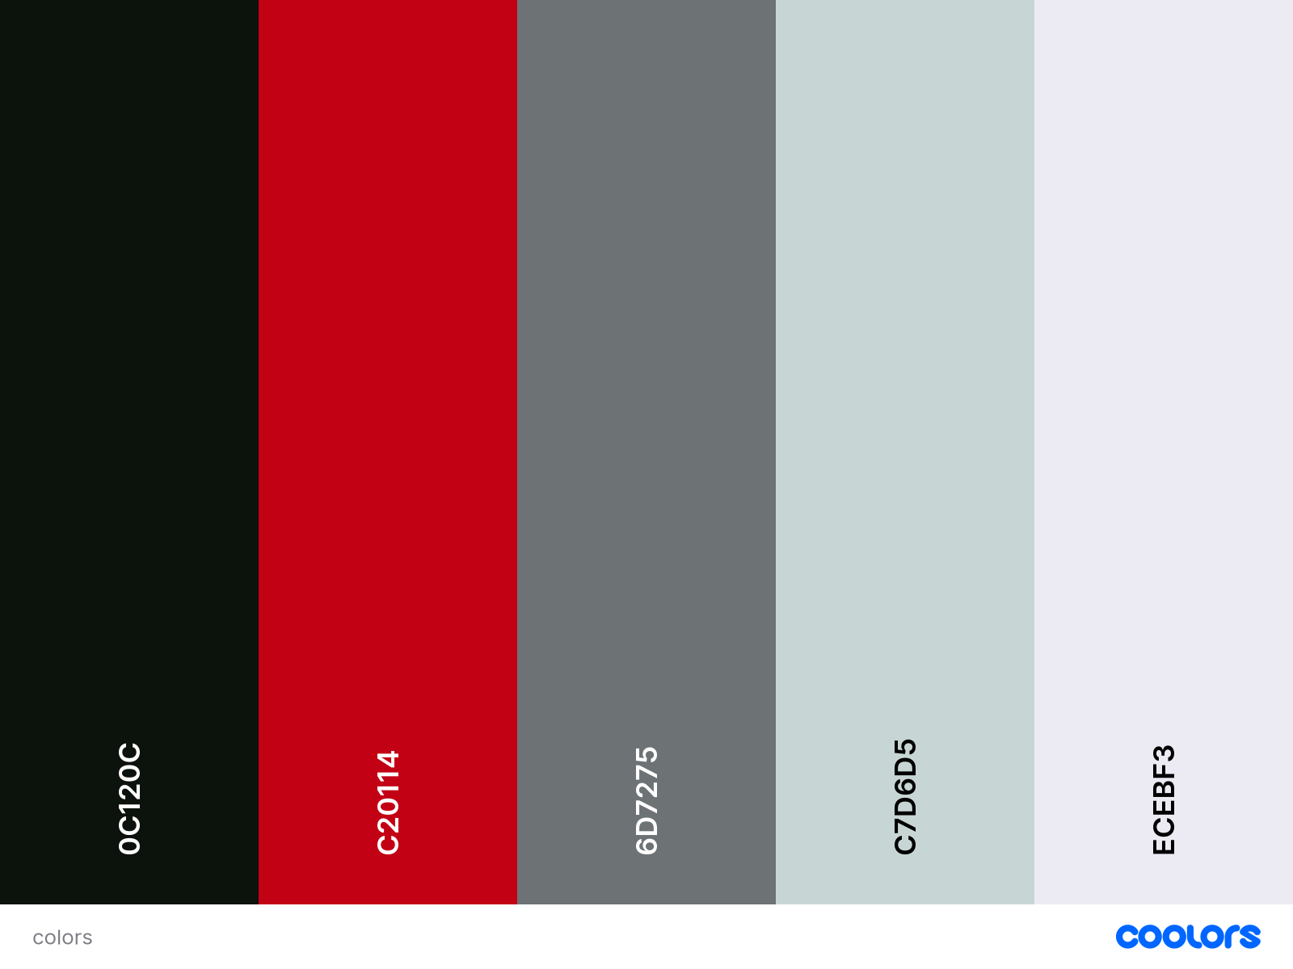
Fonts
Header: Orbiton: https://fonts.google.com/specimen/Orbitron
Paragraphs: Montserrat: https://fonts.google.com/specimen/Montserrat

